

CAPSTONE PROJECT REPORT
Report 4 – Software Design Document

– Ho Chi Minh, October 2026 –

Table of Contents
I. Record of Changes 4
II. Software Design Document 5
1. System Design 5
1.1 System Architecture 5
1.2 Package Diagram 6
2. Database Design 10
3. Activity Diagram 16
4. Architecture Diagram 21

I. Record of Changes
Date | A*  M, D | In charge | Change Description
*A - Added M - Modified D - Deleted

II. Software Design Document

1. Architecture Diagram
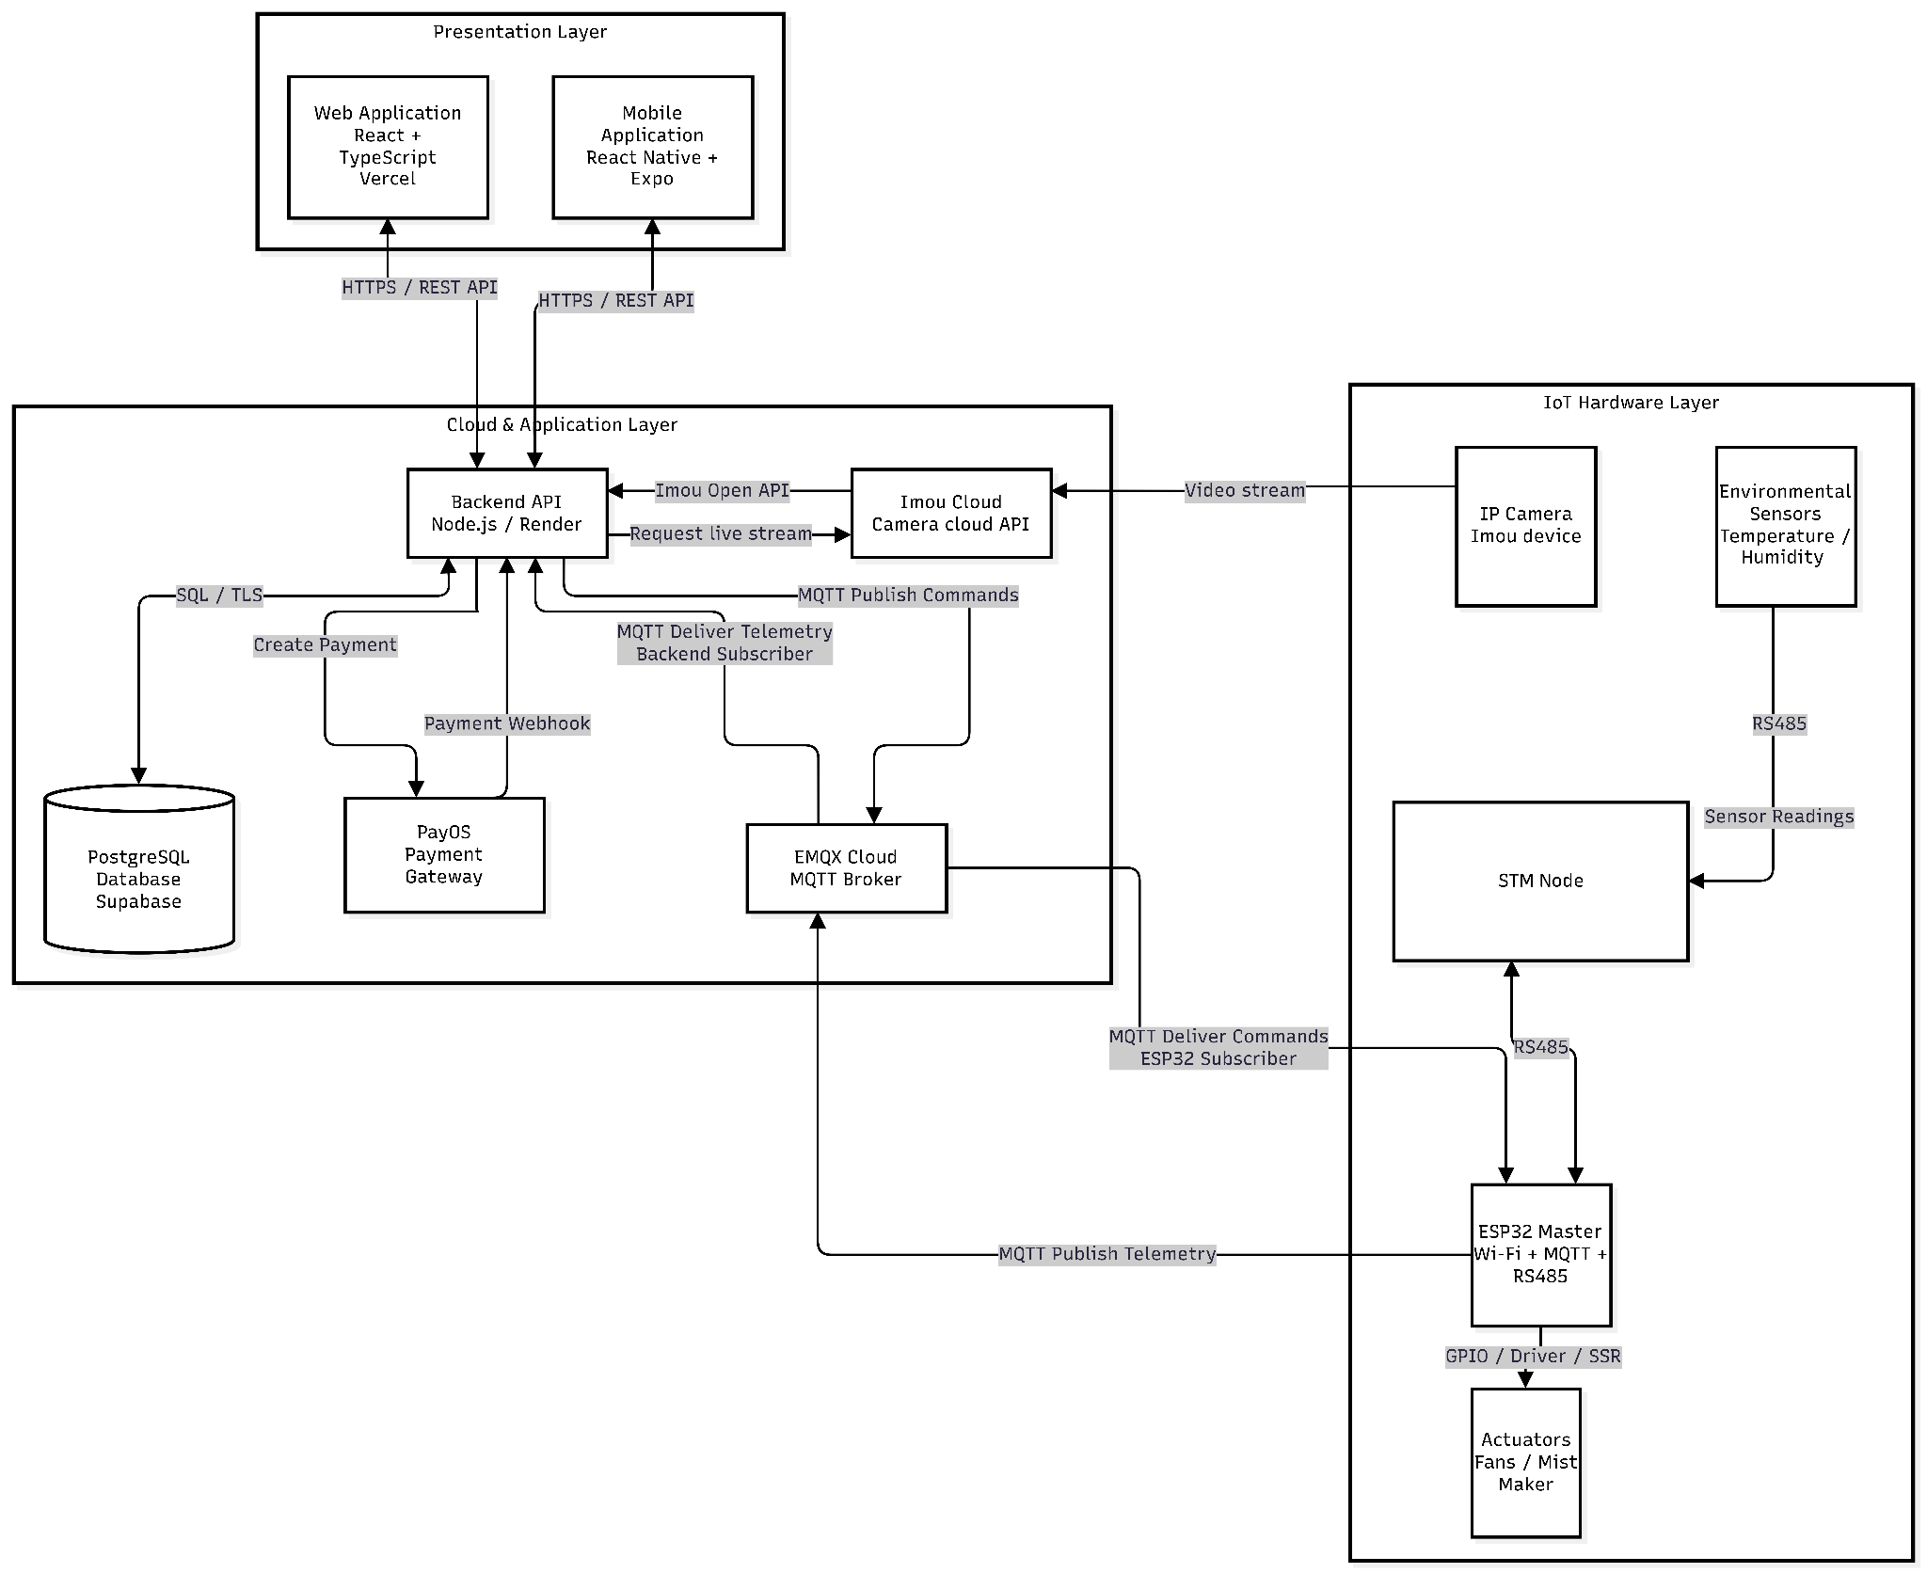
Component Descriptions
No | Component | Layer | Description
01 | Web Application | Presentation | Browser-based admin console built with React and TypeScript and deployed on Vercel. Administrators use it to manage users, orders, rental packages, rooms and trays, IoT devices, cameras, and reports.  - Technology: React, TypeScript, Vercel  - Communicates with: Backend API (HTTPS / REST API)
02 | Mobile Application | Presentation | Cross-platform mobile app built with React Native and Expo. Customers use it to rent trays, place and pay for orders, monitor temperature and humidity, and watch the camera and control devices.  - Technology: React Native, Expo  - Communicates with: Backend API (HTTPS / REST API)
03 | Backend API | Cloud & Application | The central server is hosted on Render. It exposes the REST API, authenticates users with JWT, enforces business rules, and coordinates every external service: database, payment gateway, MQTT broker, and camera cloud.  - Technology: Node.js, Express  - Communicates with: Web Application, Mobile Application, PostgreSQL (SQL / TLS), PayOS (Create Payment / Payment Webhook), EMQX Cloud (MQTT), Imou Cloud (Imou Open API)
04 | PostgreSQL Database | Cloud & Application | Relational database hosted on Supabase. It stores users and roles, orders, payments, rentals, cultivation data, sensor readings, device commands, and notifications.  - Technology: PostgreSQL, Supabase  - Communicates with: Backend API (SQL over TLS)
05 | PayOS Payment Gateway | Cloud & Application | Third-party online payment service. The backend asks PayOS to create a payment link, and PayOS sends a signed webhook to the backend when the payment result is available.  - Communicates with: Backend API (Create Payment, Payment Webhook)
06 | EMQX Cloud MQTT Broker | Cloud & Application | Managed MQTT broker that decouples the backend from the field devices. It delivers telemetry from the ESP32 Master to the backend subscriber and delivers backend commands to the ESP32 subscriber.  - Technology: EMQX Cloud, MQTT over TLS  - Communicates with: Backend API (publish commands, deliver telemetry), ESP32 Master (deliver commands, publish telemetry)
07 | Imou Cloud | Cloud & Application | Camera cloud platform of Imou. The backend calls its Open API to request a live stream for a camera and receives stream information (such as an HLS URL) in return. It also receives the video stream from the IP camera.  - Technology: Imou Open API (HTTPS)  - Communicates with: Backend API (Imou Open API, Request live stream), IP Camera (Video stream)
08 | IP Camera | IoT Hardware | Imou network camera is installed in a cultivation room to monitor the growing area. It pushes its video stream to Imou Cloud, not directly to the backend.  - Communicates with: Imou Cloud (Video stream)
09 | Environmental Sensors | IoT Hardware | Temperature and humidity sensors placed on the growing floors. They provide the readings used for monitoring and for automatic misting control.  - Communicates with: STM Node (RS485, Sensor Readings)
10 | STM Node | IoT Hardware | Sensor node based on an STM microcontroller. It collects readings from the environmental sensors and forwards them to the ESP32 Master over the RS485 bus.  - Technology: STM microcontroller, RS485  - Communicates with: Environmental Sensors, ESP32 Master (RS485)
11 | ESP32 Master | IoT Hardware | Gateway controller with Wi-Fi, MQTT, and RS485. It gathers data from the STM Node, publishes telemetry to the broker, receives control commands, and switches the actuators.  - Technology: ESP32, Wi-Fi, MQTT, RS485  - Communicates with: EMQX Cloud (MQTT), STM Node (RS485), Actuators (GPIO / Driver / SSR)
12 | Actuators | IoT Hardware | Fans and mist makers that adjust the growing environment. They are switched on and off through drivers and solid-state relays (SSR) controlled by the ESP32 Master.  - Communicates with: ESP32 Master (GPIO / Driver / SSR)

2. Database Design

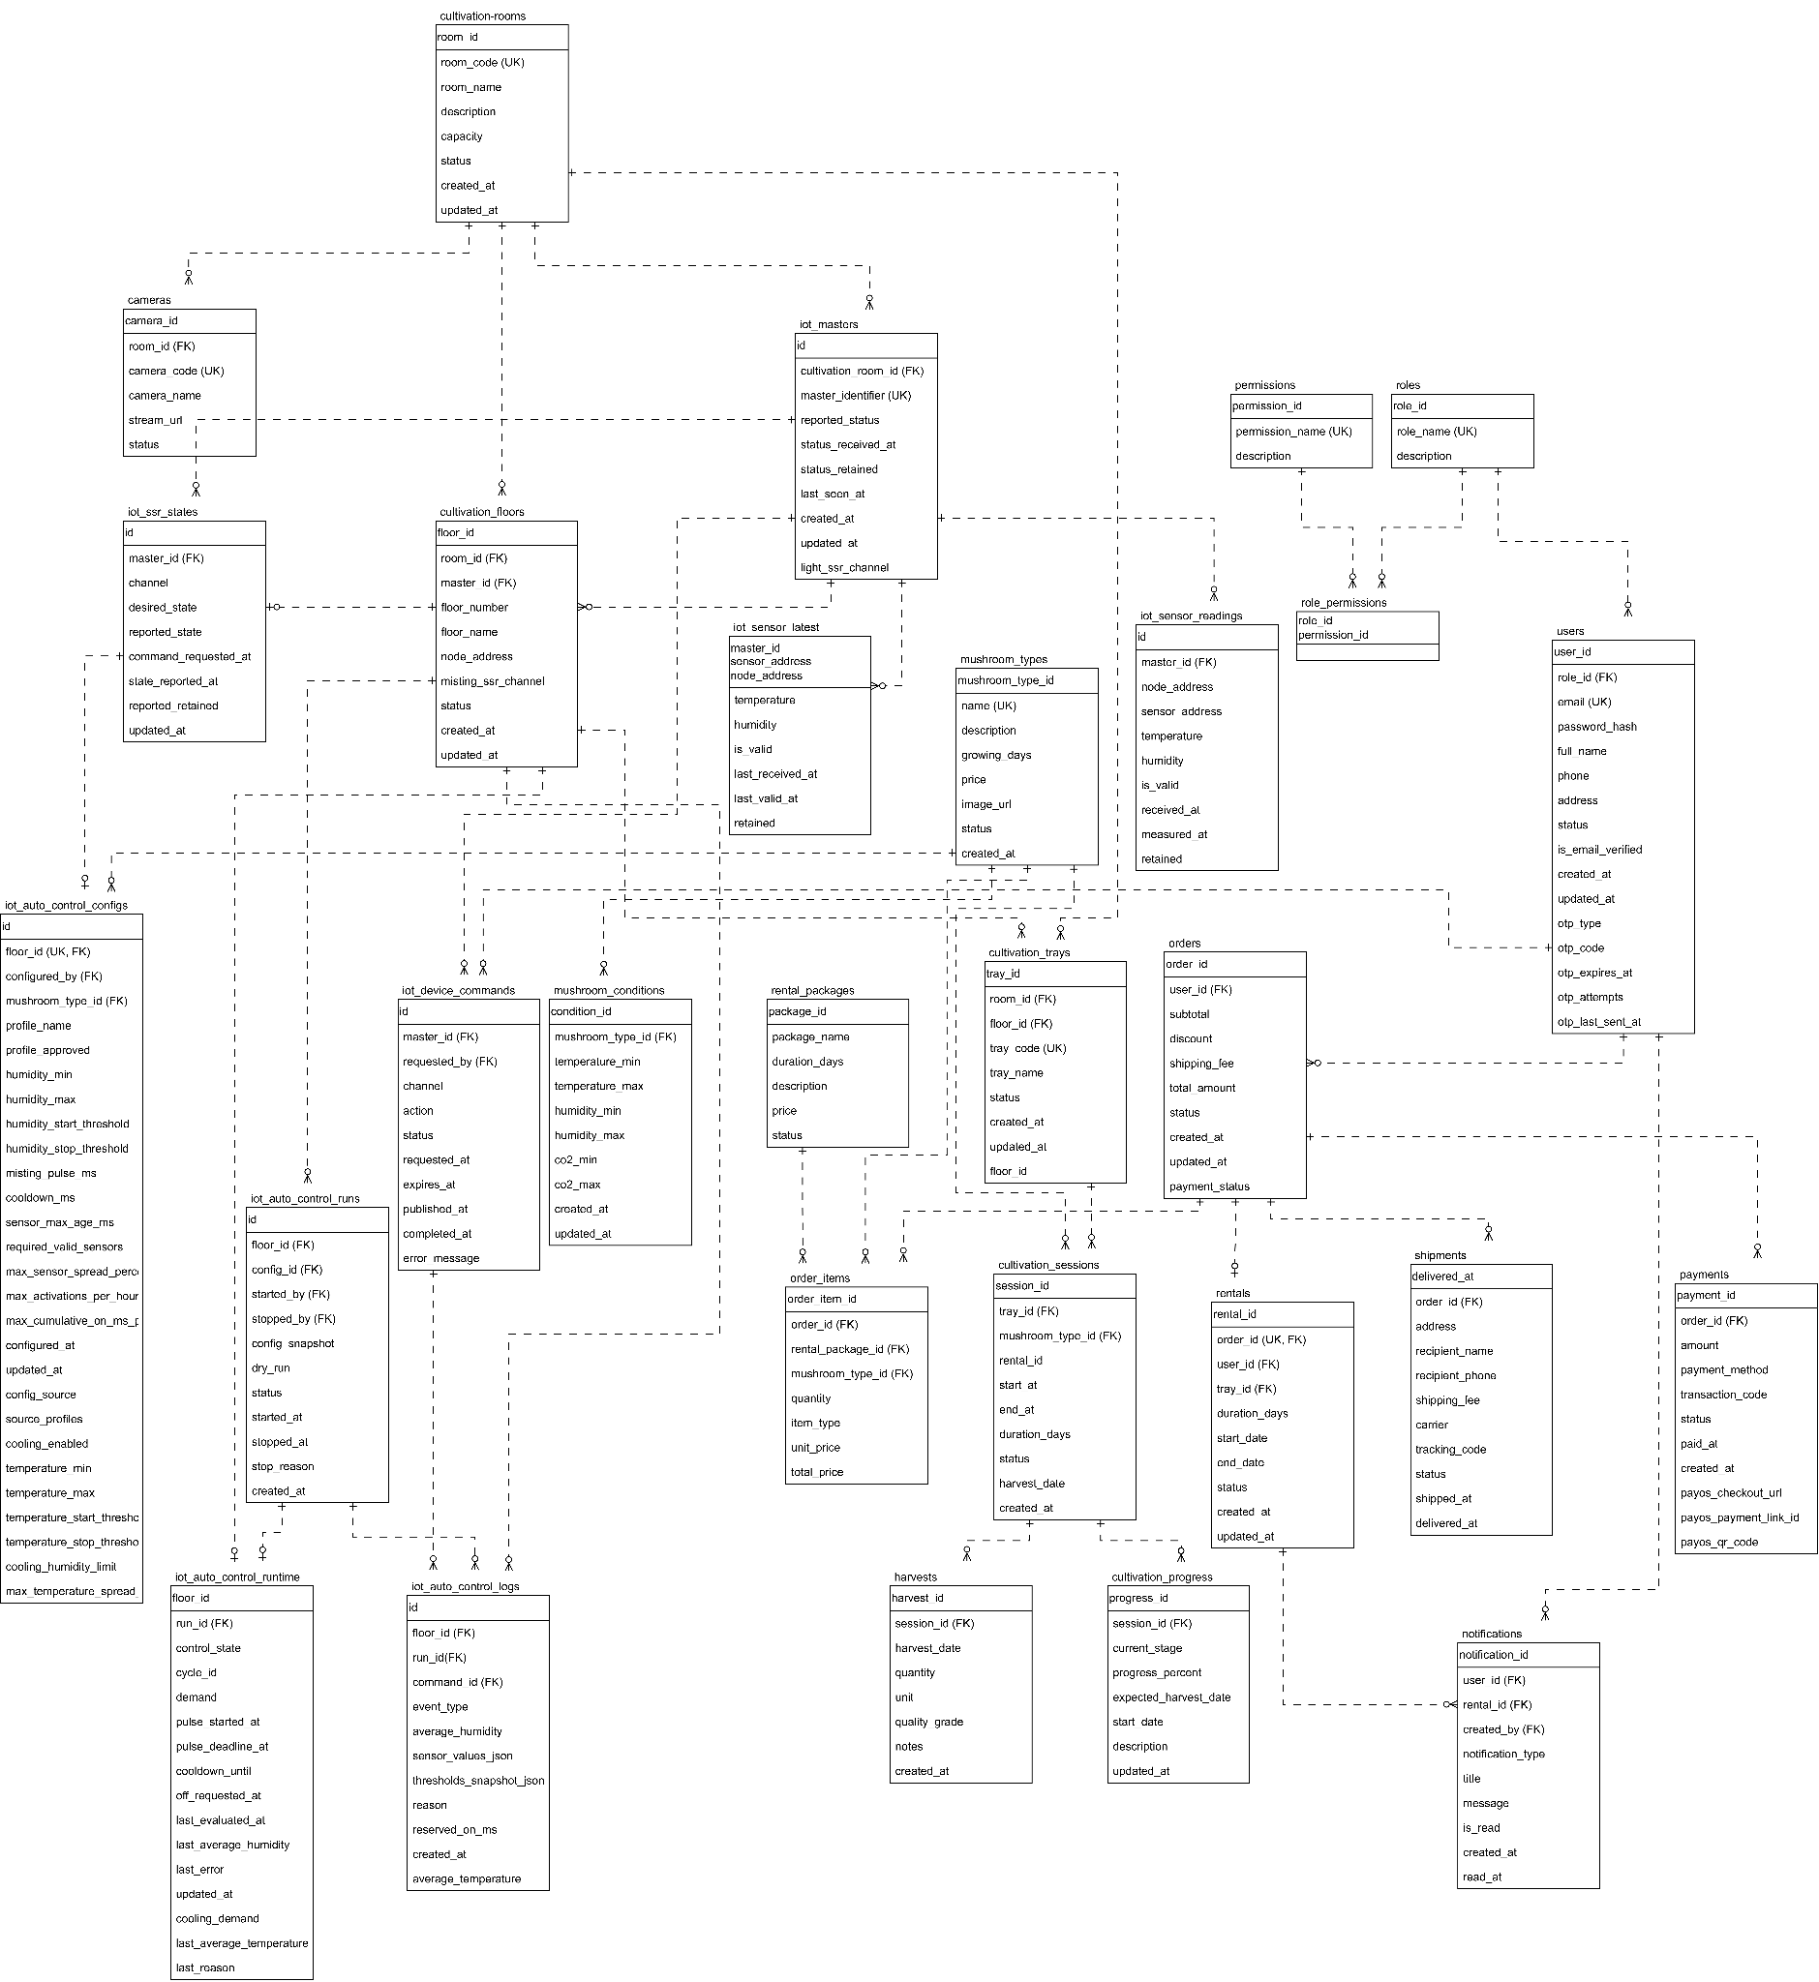
Table Descriptions
No | Table | Description
01 | roles | Defines the user roles of the system.  - Primary keys: role_id  - Foreign keys: None
02 | permissions | Lists the permissions that can be granted to roles.  - Primary keys: permission_id  - Foreign keys: None
03 | role_permissions | Junction table linking roles and permissions (many-to-many).  - Primary keys: role_id, permission_id  - Foreign keys: role_id, permission_id
04 | users | Stores user accounts, profile data, account status, email verification, and OTP information.  - Primary keys: user_id  - Foreign keys: role_id
05 | mushroom_types | Catalog of mushroom varieties with growing duration, price, and image.  - Primary keys: mushroom_type_id  - Foreign keys: None
06 | mushroom_conditions | Ideal temperature, humidity ranges for each mushroom type.  - Primary keys: condition_id  - Foreign keys: mushroom_type_id
07 | rental_packages | Rental plans are offered to customers, with duration and price.  - Primary keys: package_id  - Foreign keys: None
08 | cultivation_rooms | Physical growing rooms of the farm, with a unique room code and capacity.  - Primary keys: room_id  - Foreign keys: None
09 | cultivation_floors | Shelf levels inside a room, each linked to an IoT master, a sensor node, and a misting relay channel.  - Primary keys: floor_id  - Foreign keys: room_id, master_id
10 | cultivation_trays | Trays that customers can rent, located on a floor of a room.  - Primary keys: tray_id  - Foreign keys: room_id, floor_id
11 | cameras | Surveillance cameras installed in cultivation rooms.  - Primary keys: camera_id  - Foreign keys: room_id
12 | cultivation_sessions | One growing cycle of a mushroom type on a tray for a rental.  - Primary keys: session_id  - Foreign keys: rental_id, tray_id, mushroom_type_id
13 | cultivation_progress | Tracks the growth stage and progress percentage of a session.  - Primary keys: progress_id  - Foreign keys: session_id
14 | harvests | Records the harvested quantity and quality of a session.  - Primary keys: harvest_id  - Foreign keys: session_id
15 | orders | Customer orders with amounts, order status, and payment status.  - Primary keys: order_id  - Foreign keys: user_id
16 | order_items | Line items of an order, either a rental package or a mushroom purchase.  - Primary keys: order_item_id  - Foreign keys: order_id, rental_package_id, mushroom_type_id
17 | payments | Payment transactions of an order, including PayOS checkout data.  - Primary keys: payment_id  - Foreign keys: order_id
18 | shipments | Delivery information and status of an order.  - Primary keys: shipment_id  - Foreign keys: order_id
19 | rentals | A tray rental created from an order, with its lifecycle status (one-to-one with the order).  - Primary keys: rental_id  - Foreign keys: order_id, user_id, tray_id
20 | notifications | In-app notifications sent to users, optionally linked to a rental.  - Primary keys: notification_id  - Foreign keys: user_id, rental_id, created_by
21 | iot_masters | IoT master controllers that communicate over MQTT and report online status.  - Primary keys: id  - Foreign keys: cultivation_room_id
22 | iot_ssr_states | Desired and reported the ON/OFF state of each relay channel of a master.  - Primary keys: id  - Foreign keys: master_id
23 | iot_sensor_latest | Latest valid reading of every sensor, used for fast dashboard queries.  - Primary keys: master_id, node_address, sensor_address  - Foreign keys: master_id
24 | iot_sensor_readings | Full history of temperature and humidity readings from sensors.  - Primary keys: id  - Foreign keys: master_id
25 | iot_device_commands | Audit trail of relay commands sent to devices and their execution status.  - Primary keys: id  - Foreign keys: master_id, requested_by
26 | iot_auto_control_configs | Automatic misting and cooling configuration of a floor (one per floor).  - Primary keys: id  - Foreign keys: floor_id, mushroom_type_id, configured_by
27 | iot_auto_control_runs | Each start/stop session of automatic control with a configuration snapshot.  - Primary keys: id  - Foreign keys: floor_id, config_id, started_by, stopped_by
28 | iot_auto_control_runtime | Live state of the automatic control algorithm for each floor.  - Primary keys: floor_id  - Foreign keys: floor_id, run_id
29 | iot_auto_control_logs | Event log of the automatic controller, including readings, reasons, and issued commands.  - Primary keys: id  - Foreign keys: floor_id, run_id, command_id

3. Activity Diagram
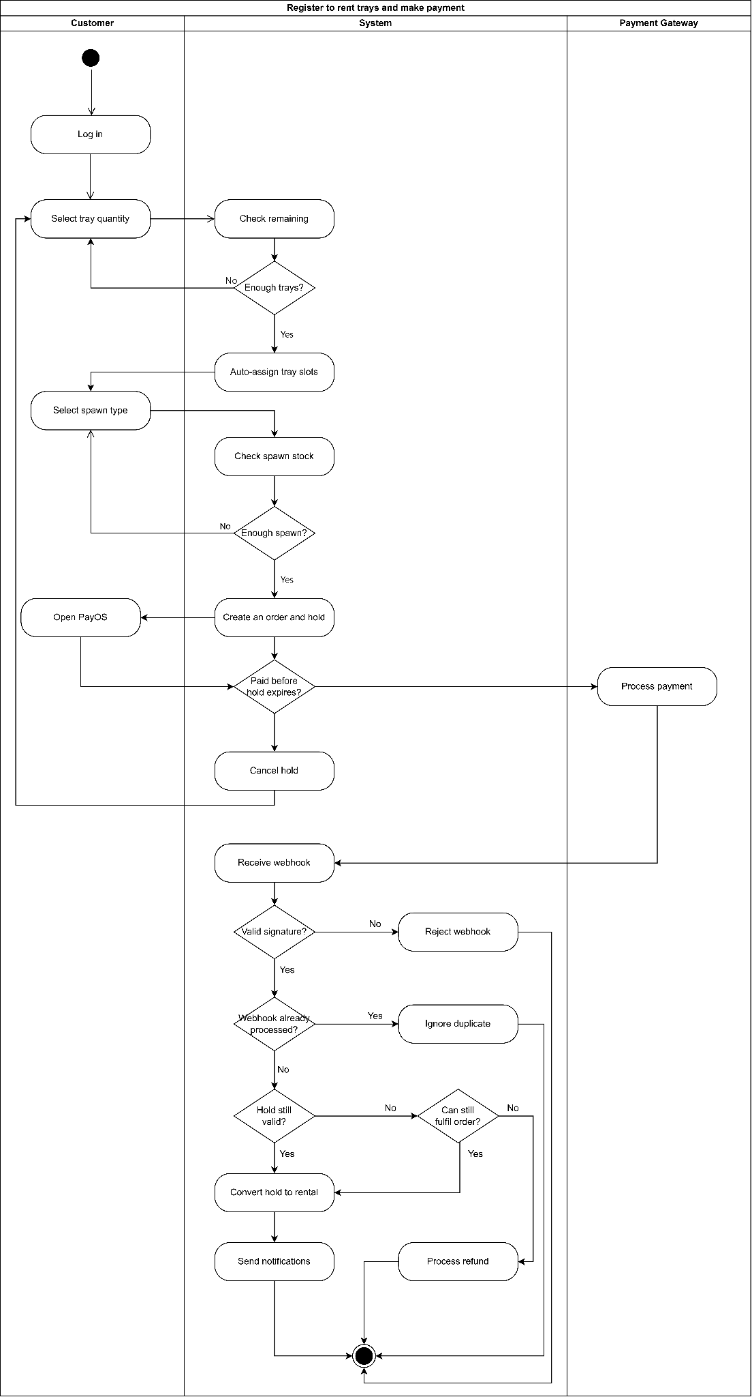
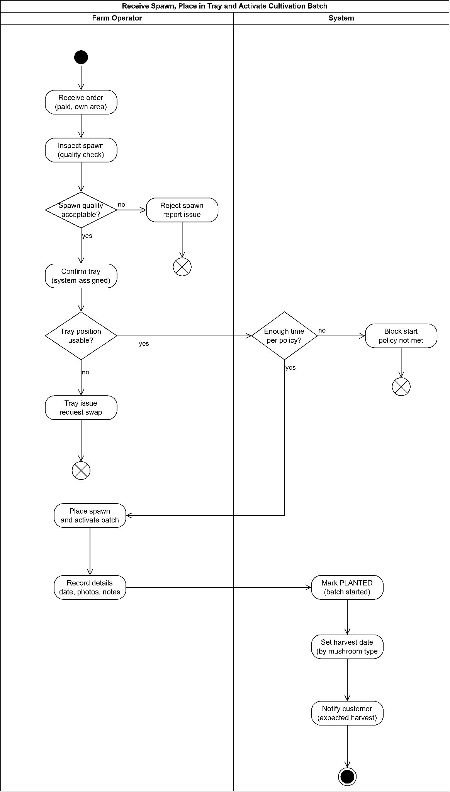
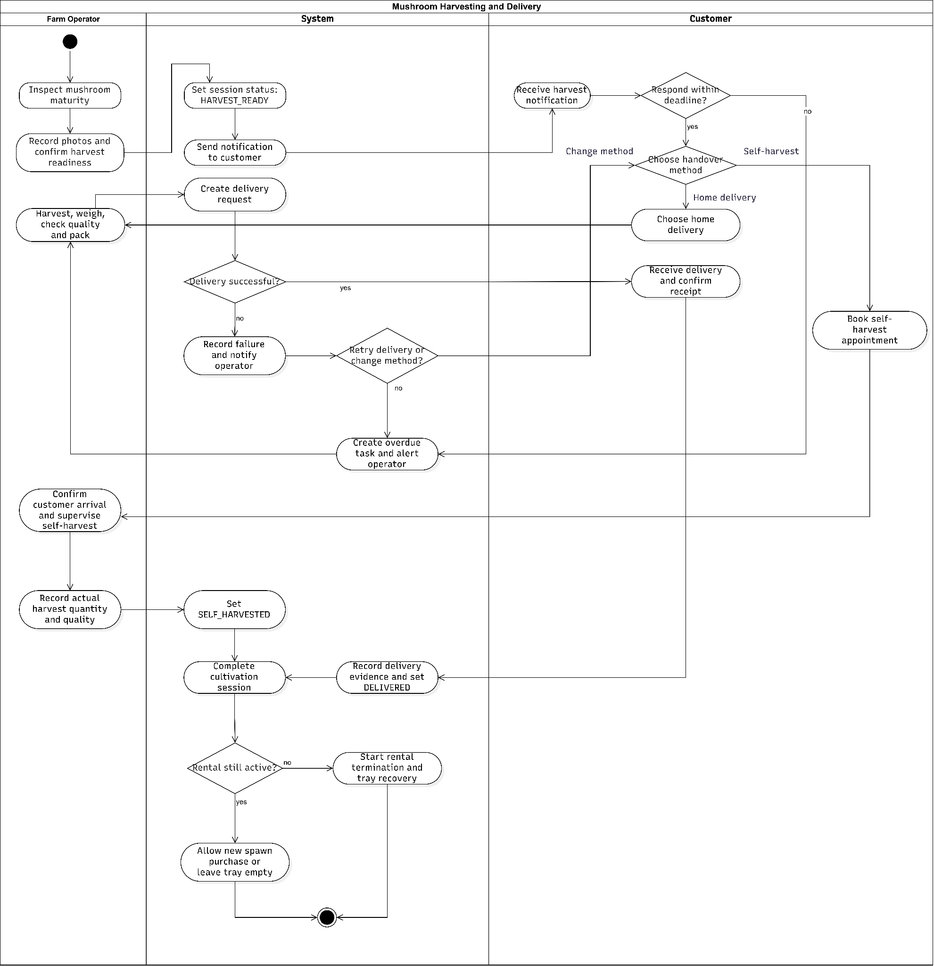
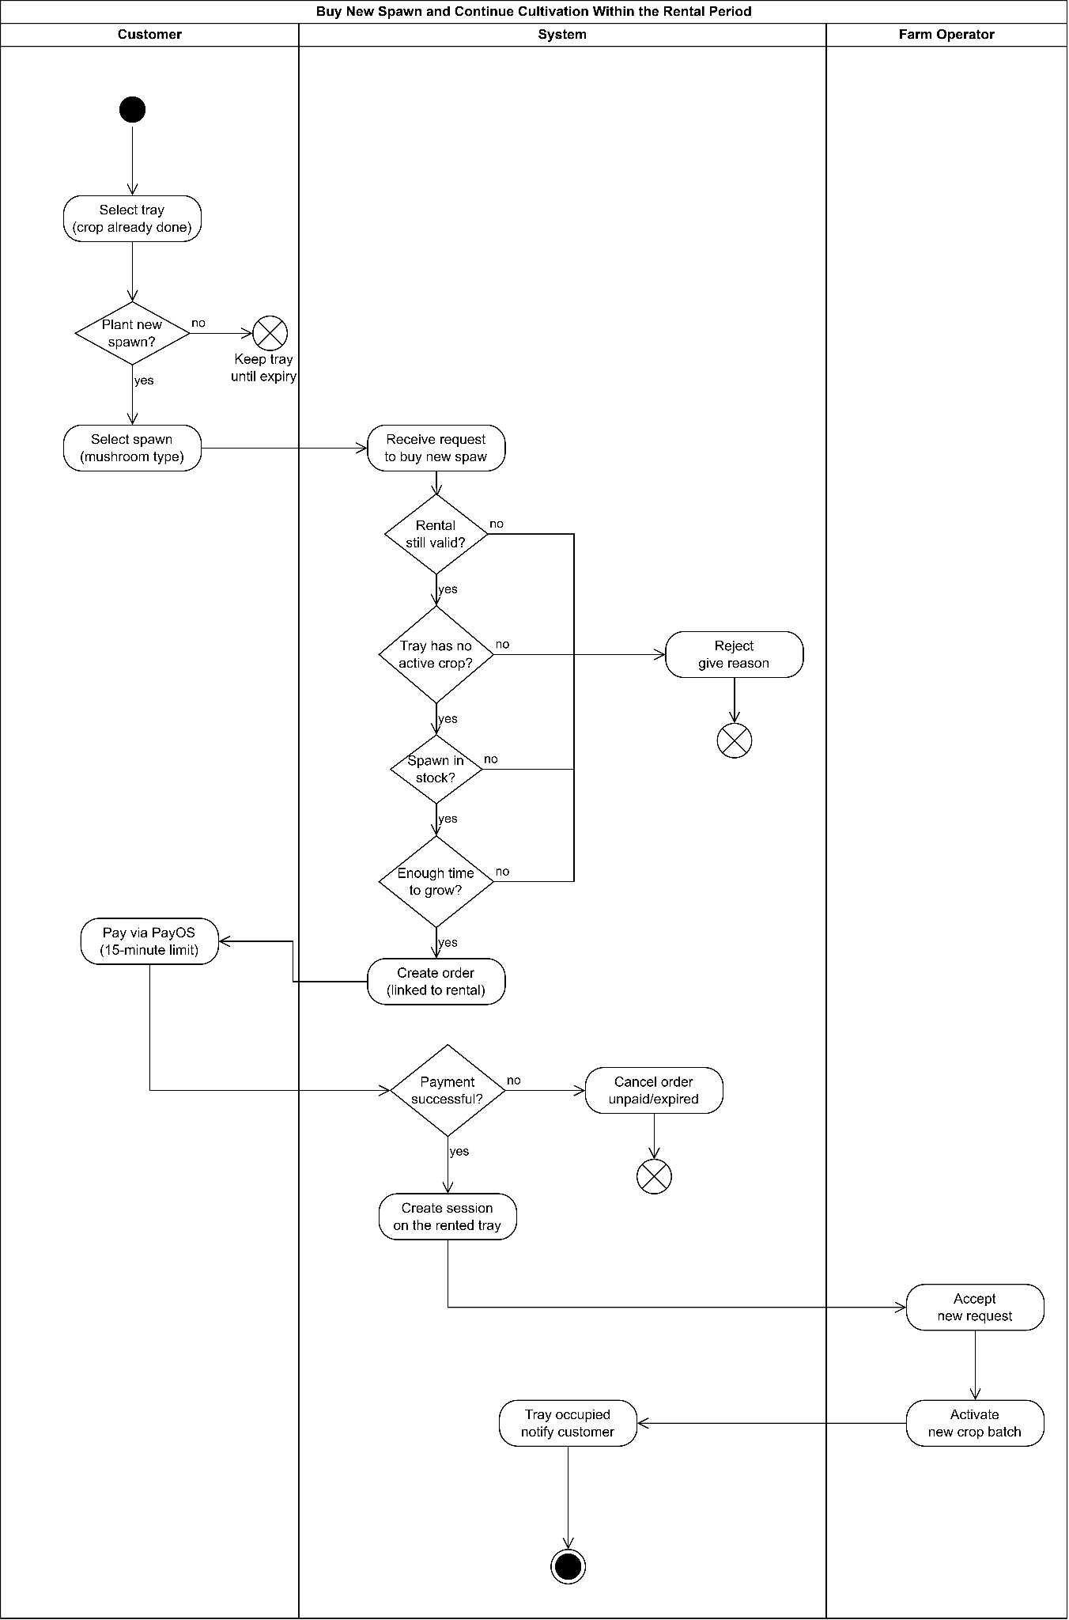
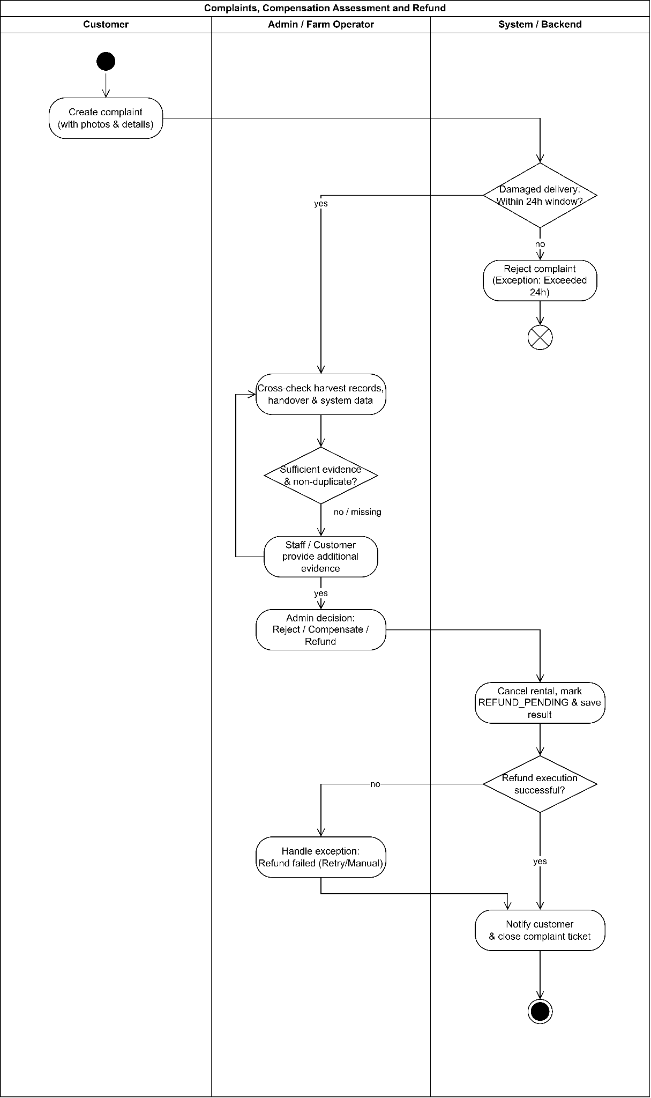

4. State Machine Diagram
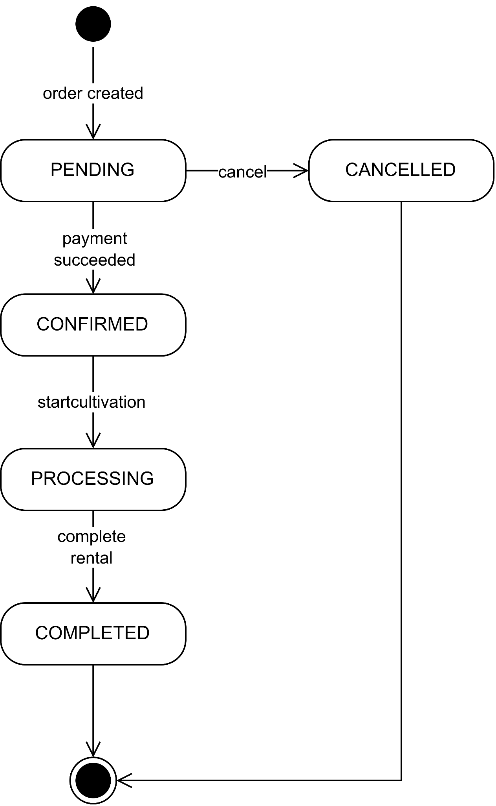
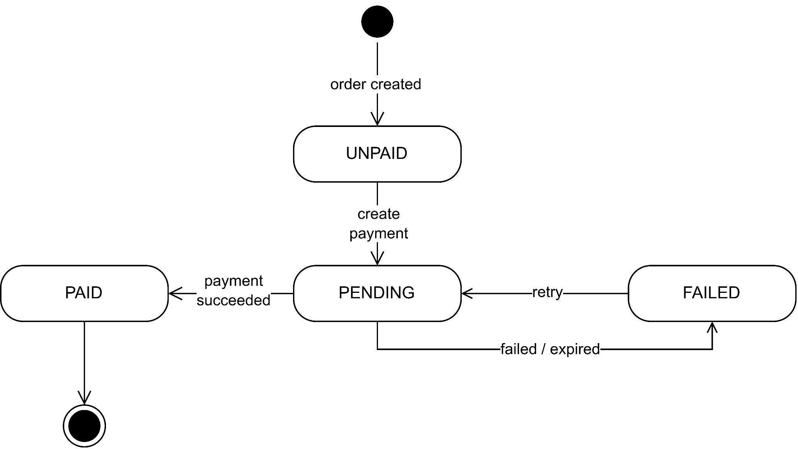
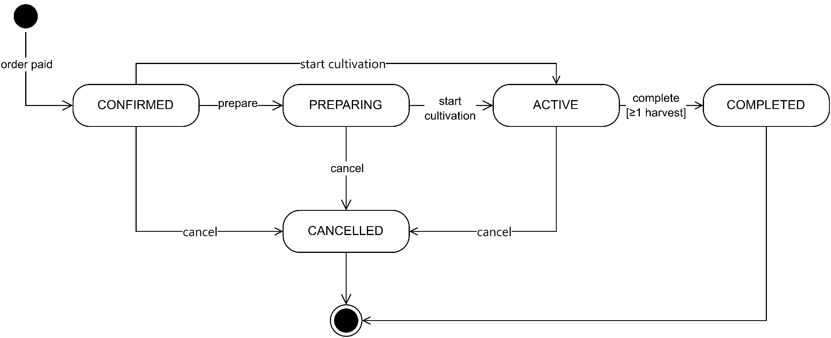
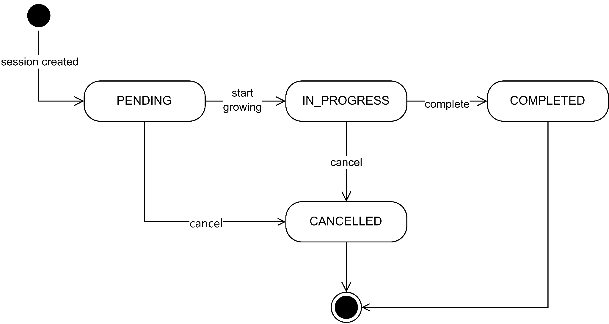
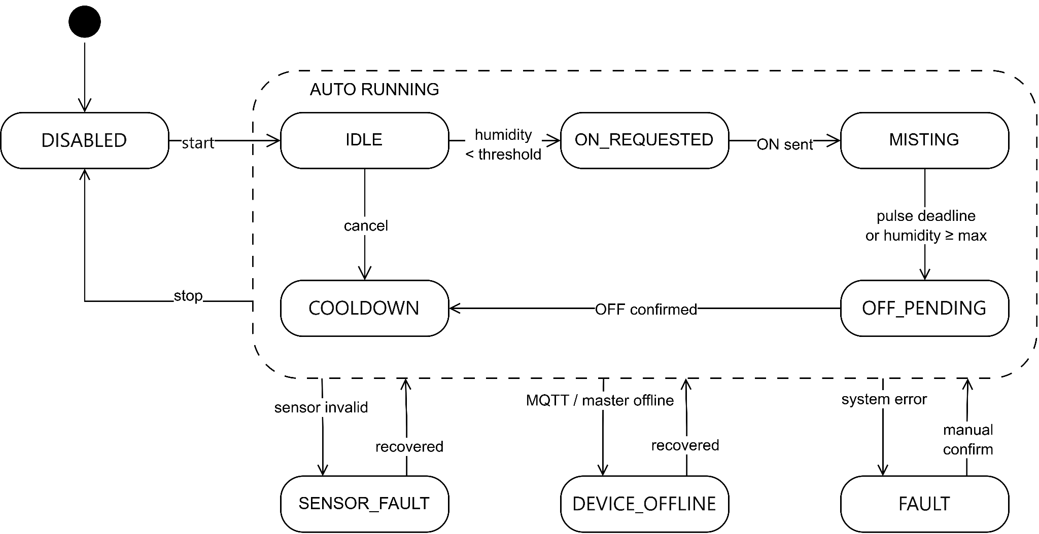
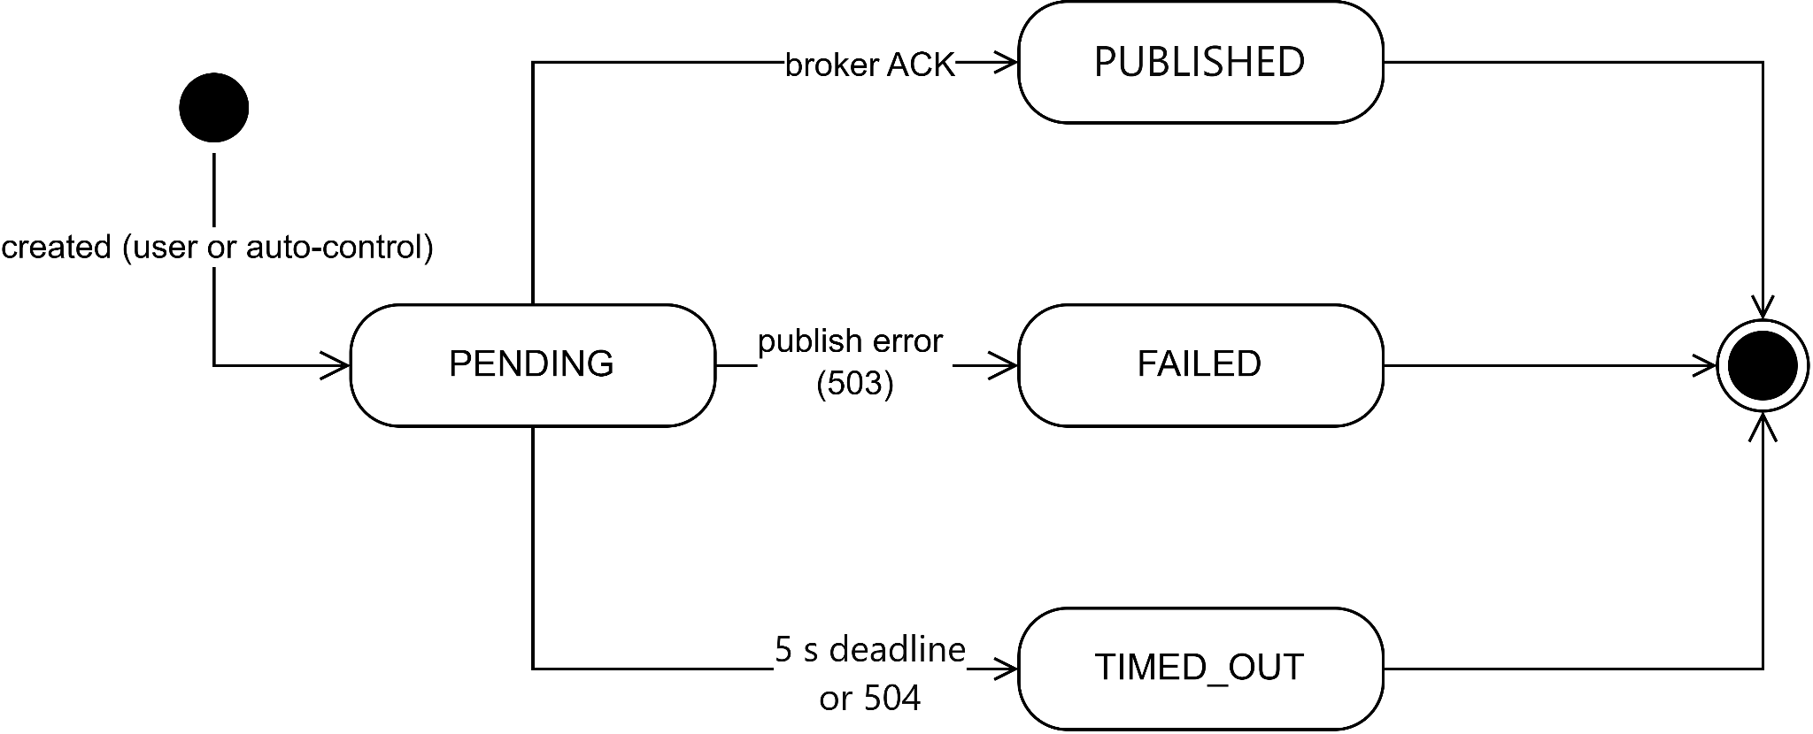5. Technology Declaration
Group | Component
Third-party services | Authentication: JWT (JSON Web Token) for user authentication and role-based authorization; passwords hashed with bcryptjs before being stored.  Storage: Cloudinary for images and media.  Payment: PayOS for payment processing and payment webhooks.  AI APIs: Google OAuth/Gmail API to authorize sending OTP emails; AI also supports automation tasks during development.  Database: PostgreSQL on Supabase (user data, system data, transaction history, application data).  Data/IoT: MQTT to connect IoT devices/sensors and monitor device status.  Data sent: user information, OTP codes, authentication tokens, images/media, payment data, sensor data, and device status.
Development technologies | Front-end: Web/app client following a client-server architecture, interacting with the backend API.  Back-end: Node.js + Express.js for building the API, authentication, business logic, and database connectivity.  Mobile: Mobile apps (current or future) can be developed on top of the backend API.  Database: PostgreSQL on Supabase.  Cloud: Supabase, Cloudinary, Google API, PayOS.  Versions: Node.js (backend runtime), Express 5, PostgreSQL, JWT, bcryptjs, MQTT, Google APIs, Cloudinary.
Source code & DevOps | Platform: Git-based platform such as GitHub, GitLab, or Azure DevOps.  CI/CD: Automated pipeline triggered on code changes to build, test, and deploy.  Branching rules: main/master for production, develop for staging/testing, and feature branches for new work.  Quality control: Code review, error checking, and testing before merging into the main branch.
Deployment environments | Environments: Dev (testing logic, APIs, and new features), Staging (pre-production testing), and Production (live for real users).  Deployment location: Cloud hosting or any platform supporting Node.js, PostgreSQL, and related services.  Deployment method: Automated build and deploy via CI/CD, with environment variables updated (e.g., JWT_SECRET, DATABASE_URL, PAYOS keys).  Rollback: Revert to the previous stable version by rolling back the release or the container/service.
AI tools | Tools & usage scope: AI assists across specification, design, coding, testing, and review; it helps create mockups, write APIs, suggest design solutions, generate test cases, review logic errors, and optimize performance.  Specification: Describing features and system requirements.  Design: Suggesting architecture, API contracts, and flow diagrams.  Code: Generating code, refactoring, writing utilities.  Testing: Creating test cases and checking edge cases.  Review: Detecting logic errors and improving code quality.  Goal: Speed up development, reduce errors, and improve software quality.

